Quick Sta rt Guide

Model: NG-Cl 200 Series
Ver sion: 1.0
English

lmportant Notes

lf you have any problems, please read this manual carefully or

contact Customer Ca re
The device can only connect to 2.4GHz Wi-Fi networks. lf you have a dual- band router w ith separate 2.4GHz and SGHz networks, make sure your phone is connected to the 2.4GHz network

Make su re the ente red Wi-Fl password is corre et when addlng a new device
4 Please make sure the device is close to the router for a stable
network connection

Do not mount the camera before confirming a successful network connection and smooth live video

We couldn't guarantee the exact consistency between the actual product and the written information in this manual due tothe regular app and product updates.

Table of Contents
What's In the Box 3
Product Overview 3
Setup..........................................•. 4
Connecting the Device to NGTeco Home App 4
Watching the Videos from Browser 5
*Connecting the Device to Amazon Alexa ar Google Assistant 6
lnstallation 7
lnstallation Location ........................ ............................................................ ?
lnstallation Steps .............................. ............................................................ ?
Product Features.......................•. 8

What's in the Box

Camera Power A dapter USB Charging Screw Kit Quick Start
Cable (mounting Guide

screws, anchors)

N o te : The power plug may vary in different regions.

Product Overview

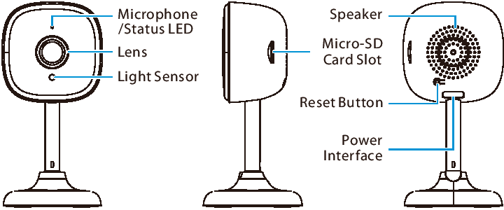

Setup1
Connecting the Device to NGTeco Home App

Step 1: Download the App and Register Your Account
Search for the NGTeco Home App in Apple App Store or Google Play Sto re and download the App to your mobile phone

Open the NGTeco Home App and log in with your account. lf you do not have an account, create an account with your phone number or Email ID

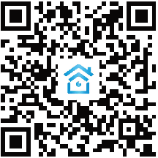 • 1•1.111

Step 2: Power on the Device
1 Plug the camera into the power socket using the provided power adapter and USB cable

Wait for a few seconds until you hear the prompt NCamera
start, please configure network N.
Note: lf you did not hear the prompt, press and hold the Reset Button for 5 seconds until you hear the prompt "Restare Factory SettingsN.

Step 3: Add th e Dev ice to th e App
1 Open the app, tap the "+" button on the top right comer of the interface, and then select the NAdd DeviceN option. Select the "Smart Camera " option and then choose the correspondlng model purchased

Tlck " Next " if you have finlshed the above steps on the interface. Select the desired Wi- Fi and enter the correct password. Then tap the "Next" button

Show the QR code towards the device lens, and the camera will sean the QR code. Once you hear the audio prompt "Camera configured, connecting to Network ", ta p the "I Heard a Prompt " button on your mobile, the App will connect the device automatically

Note: Please hold the phone about 1 5-20 cm (6-8 inches) away from the camera. You can slightly move your mobile device forward and backward for better scanning

4 You can manually change the na me of the device once you see the message " Added successfully " on the mobile app. To finish the setting, tap the " Done" button

Note: lf you failed to connect your device to W i-Fi, press and hold the RESET Button for 5 seconds until you hear the audio prompt "Restare Factory Settings", then repeat the above steps

Watching the Videos from Browser
Visit htt os://ioc - us.ismartlife.me and then select the corresponding data server on the top right comer of the interface

Use NGTeco Home App to sean the QR code to login to your account

Click the corresponding device to watch the live videos

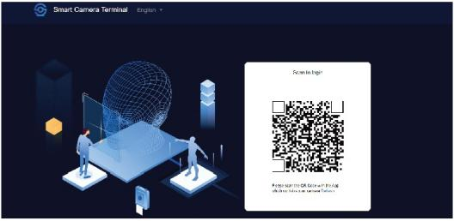

*Connecting the Device to Amazon Alexa or Google Assistant
Tap the EDIT Button in the upper right comer of the device interface after successfully connecting the device to the NGTeco Home App. To link your NGTeco Home Account to Amazon Alexa or Google Assistant, select the Amazon Alexa or Google Assistant icon and follow the on-screen instructions

After completing the setup, you can use the supported voice commands that lnclude

Echo, show me <devicename>.
- HeyGoogfe,showme<devicename>.
Note:
1 Every time you change the na me of a linked device, you must
dlscover it again to update the name
This voice control feature is optional, only the model NG­ C12XXA can support .

lnstallation

lnstallation Location
The device can be put on the ceiling or the wall, or it can be placed horizontally. Choose a location with a clear, unblocked field of view and with a good wireless signal to the device, and can reach a power outlet easily

lnstallation Steps
After confirming a successful Wi -Fl connection and smooth live video, you can select the required position to mount the device The installation steps are as follows
1 Drill two holes in the wall according to the hole positions of camera base, and then insert the plastlc anchor into the holes; anchors are necessary for walls that are made of hard materia Is such as concrete, brick or stucco. Leave sorne gap between the screws and the wall
Align the screws with the grooves of the camera base, and then push the device down untll it clicks into place

Adj ust the viewing angle by checking the live video in the mobile app

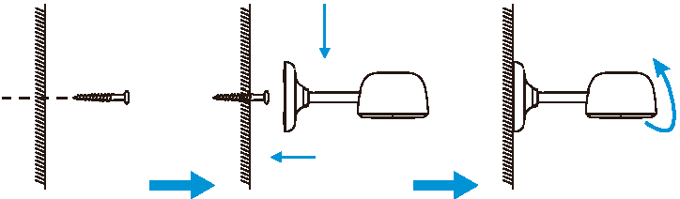

Product Features

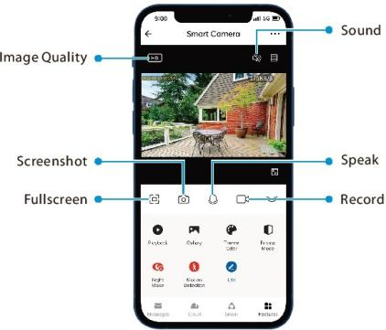

Main Inte rface:
lmage Quality :To switch the image quality between HD and SD Sound:To mute or unmute the sound from the device Fullscreen :Tap it to switch to the full screen
Screenshot : Capture a picture to the photo album in App Speak :Tap it to talk to people in front of the device
Record:Manually record a video tothe photo album in App Playback :Watch the recorded videos in the Micro-SD Card Gallery : Review the recorded photos when detecting the motion

Theme Color:Change the UI theme to light mode or dark mode.

Private Mode: Disable the live videos with one click to protect your privacy

Night Mode: Switch on/off the night vis ion mode or set it to Auto Mode

Motion Detection : Enable or disable the alarm of motlon

detectlon.
*Cloud:This Video Cloud Storage service is needed to pay for the monthly or annually subscription. You could check the video from cloud storage with App anytime, anywhere. The cloud storage only supports recording the events video clips

Smart: Manage the related smart automation settings

More Settings:
Basic Settings:
- Status lndicator:The status LED ca n be set as ON or OFF
- Flip Screen : Rotate the current monitoring image at 180 degrees
- Time Watermark : Choose whether the monitoring interface displays the real time watermark

- Talk Mode: To fit the actual requirements, select the one ­ way or two-waytalk mode.

Detection Alarm Settings:

- Motion Detection : Enable or disable the alarm of motion detection
- Alarm Sensitivity Level: The level can be set to High/ Medium/Low modes as required.

- Schedule : Customize the schedule for the motion detection to be active
Storage Settings: After inserting the Micro-SD card, you could check the status of storage ca pací ty

Recording Settings: Select the recording mode and set the schedule ofthe local recording.

*Voice Control :To see live video from the Amazon Echo or Google Home device, use Amazon Alexa or Google Assistant voice commands. This feature is optional

Offline Notification : lt enables to receive the offline push message ofthe camera

Remove Device: Remember to REMOVE the device from the current account when the owner ofthe camera changes

